

Live Better Again

Iteration 2 Report

Version 1.0

**Team 106**

Team Members:

Allison Tang

Joshua Brown

Trista Li

Frank Nacional

Bryan Sim

Contents

**Introduction 2**

**Delivery cycle overview** **3**

Overall delivery cycle plan 3

Updated functional decomposition diagram 4

Current delivery cycle plan 5

**Review and feedback form 6**

**User access and instruction 8**

**Appendix 9**

Introduction

The purpose of this report is to give all relevant stakeholders an in depth look at what has been achieved for iteration 2. The document outlines the following completed functions:

* CPAP tracking
* ESS scoring form (part of 2.0 Patient Registration)
* Upload patient files (part of 2.0 Patient Registration)

This documentation includes an overview of the delivery cycle plan, function descriptions as well as review and feedback forms.

Delivery Cycle Overview

Overall Delivery Cycle Plan (revised)

|  |  |  |  |
| --- | --- | --- | --- |
| **Iteration** | **Functions** | **Priority** | **Date of Iteration End** |
| Iteration 1 | Account registration (Functions 1.1-1.3) | High | 20th September 2017 |
| Patient registration  (Functions 2.1-2.2, 2.7) | High |
| Electronic consent forms (Function 2.3) | High |
| Iteration 2 | Patient registration  (Function 2.2, 2.6) | High | 14th October 2017 |
| CPAP tracking (Functions 3.1-3.4) | Medium |
| Iteration 3 | Medicare forms and PDF files (Functions 2.4-2.5) | High | 27th November 2017 (TBC) |
| Clinic reports (Function 6.1) | Medium |
| Technician appointments and calendars (Functions 4.1-4.2) | Medium |
| Recording of patient treatments and notes (Function 2.8) | Medium |  |
| Iteration 4 | Invoicing  (Functions 7.1-7.3) | Medium | 7th December 2017 (TBC) |
| CPAP sales inventory tracking (Function 7.4) | Medium |
| Website upgrade | Low |

Updated functional Decomposition Diagram (For Iteration 2)

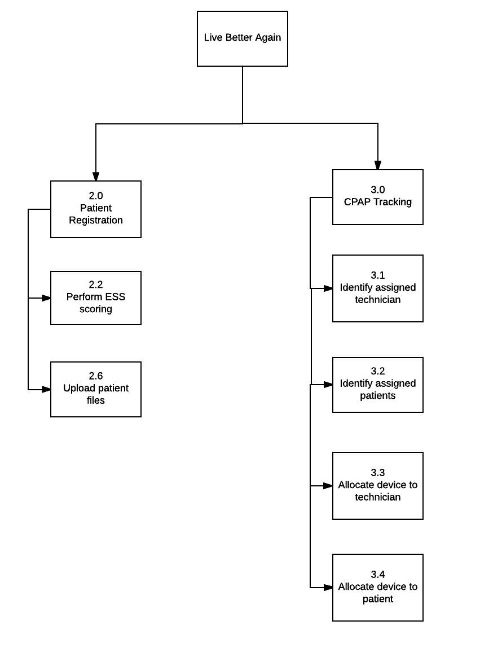

Current Delivery Cycle Plan

|  |  |  |  |
| --- | --- | --- | --- |
| **No.** | **Function name** | **Description** | **Status** |
| 2.2 | Perform ESS scoring | - Technician is able to complete an digital ESS form and receive a patient’s ESS score | Completed |
| 2.6 | Upload patient files | - Technician is able to import upload files(e.g. referral form) to the system and save it to the patient record | Completed |
| 3.1 | Identify assigned technician | - Administrator and technician are able to check which technician is responsible for a given device | Completed |
| 3.2 | Identify assigned patient | - Technician is able to identify the patient who has each device | Completed |
| 3.3 | Allocate device to technician | - Administrator is able to assign the device to a technician when registering the device on system | Completed |
| 3.4 | Allocate device to patient | - Technician is able to assign an available device to patient | Completed |
| 4.0 | Technician appointments and calendars (Functions 4.1-4.2) | - Administrator is able to view each technician's availability, and book time for patients via a calendar | To be completed in Iteration 3 |
| 2.4 | Generate medicare papers | - Technician is able to generate medicare papers within the system as a PDF file and save it to the patient record | To be completed in Iteration 3 |
| 2.5 | Generate PDF report | - Technician is able to generate the business reports in PDF format | To be completed in Iteration 3 |

Review and Feedback Form

|  |  |  |  |  |  |
| --- | --- | --- | --- | --- | --- |
| D **Delivery Cycle 2** | | | | | |
| Function | | User Stories | A Acceptance  C Criterias | Ac Acceptance  Status  **U**(Unconditional)  **C**(Conditional)  **R**(Rejected) | F Feedbacks |
| *2.2* | A Perform ESS  scoring | As As a technician, I want to  record patient’s ESS on a  digital form and save it with  patient record so that we can  provide accurate diagnosis  for patients. | - - ESS should be  calculated  accurately |  |  |
| M **Perform ESS scoring comments:** patient’s ESS scoring can now be  recorded on patient registration form and saved with patient  record | | | |  |  |
| *2. 2.6* | ReUpload  Patient files | As As a technician, I want to  upload patient files and save  it with patient records so that  I can manage all patient data  on a single platform. | - - patient files  should be  stored securely |  |  |
| **Upload patient files comments**: patient files can now be uploaded to to the system when registering new patient or editing patient  details | | | |  |  |
| *2. 3.0* | *E CPAP tracking* | As As a technician, I want to be  able to check the available  devices and assign a device to  a patient so that I can ensure  stock is allow for accurate  distribution to patients.    As an administrator, I want to b be able to register a new  CPAP machine and assign it  to a technician so that I can  track its usage easier. | - Si - only CPAP  with status of  Available can  be booked |  |  |
| **CPAP tracking comments:** A new CPAP machine can now be  registered and assigned to technician. Each machine’s status  (available or unavailable) and usage can also be tracked | | | |  |  |
| **System general comments:** System overall is working as its function states so but bugs are to be ironed out as constraints are not completely placed in order | | | |  |  |
| **Additional comments from Live Again Better:** | | | | | |
| **Delivery Cycle 2 reviewed and approved subject to implementation of documented changes:**    Cl **Client Signature:**          **Date:** | | | | | |

User Access and Instruction

The delivery cycle software can be accessed via the link below:

<http://ie.infotech.monash.edu.au/team106/build2-0/>

A sample administrator account can be accessed with the follow details::

**Username:** admin

**Password:** admin

A sample technician user can be accessed with the following details:

**Username:** tech

**Password:** tech

The user manual can be accessed via the link below:

<https://docs.google.com/document/d/1vrionRRF9xD1jkTJlXxwrX07-P8Y5x1XjqRu_7y18cU/edit#>

Appendix

Client interaction:

<https://drive.google.com/drive/u/1/folders/0B03Isl3rRcyRYmRpSTFKdFZ6bEk>